## Merchant

Demo date:   
Scoping start date: May 13, 2024x

MSA Signature Date: May 28, 2024  
Onboarding Kick Off Date: May 30, 2024  
Go Live Date:

GTM POC: Rebecca  
Implementation POC:

ERP: QBO

Tax Integration: No Tax - likely to implement Anrok soon

### 

### Key people at Merchant

### Controller: Nima Motiee

* VP Finance: Evan Pincus

### Company summary

Cortex is the leading internal developer portal empowering engineering teams to do their best work.

Goals

* Invoicing automation without disrupting a sales quoting tool the Finance does not like but has sales team buy-in (Salesbricks, sits on top of SFDC)
* Revenue recognition especially deferred/accrued where a big cleanup project is underway since Nima recently joined the org
* Cash application automation - overall looking for less tedious work for Nima so he can focus on bigger picture since they are a 2-person finance and accounting org
* Wants to sync contracts in automatically (not upload individually) so need help with Salesbricks/SFDC to trigger docs to us

AE Notes

Any important relationship information  
  
1) What is Merchant Temperament? - extremely friendly, Slack power user, “get” working with early stage startups, excited to inform our product roadmap + give feedback. They love Ramp and see us as a tool for similar workflow automation in AR.  
2) Is the key POC the buyer/decision maker? Nima is the key POC but Evan was the contract signatory. We will largely work with Nima.  
3) What are the Tabs features the key POC cares about? Contract ingest, automated billing, rev rec (deferred/accrued especially)

### Billing model

* They have a seat-based model but no usage (just charge flat price based on # seats). At some point they may move to evolve this to something with overages but right now active seat data just informs upsells, renewals, etc.
* They have some orders through the Tackle.io marketplace (AWS etc.) and we will need to figure out how to ingest those orders so we can do revenue metrics (but they won’t invoice on those, since AWS takes care of that). Also curious how we can support cash app for those Tackle deals (Tackle sends the funds).

### Billing model

* Are the unique things about the customer creation process for this merchant?
  + They sell their product through AWS and GCP marketplaces. These deals still have contracts, but might not have signature dates, as they are electronically signed on the marketplace. For implementation, instructions are below. Going forward, we will develop a process to obtain a document form of this signature to process.

### Contract Processing Steps

1. Steps to process
   1. Implementation:
      1. During the first batch of contract processing, many customers will not be in QBO. If not found, please create customer to push to QBO
      2. Some contracts may not have effective dates or signature dates. In these cases, refer columns **AG and AH** in [this spreadsheet](https://docs.google.com/spreadsheets/d/1SMyg34H4Jfkw_siph9k-RDN-funMTXPO/edit#gid=627137666) for billing dates. ***This is only to be used if the information is not found in the contract.***
         1. In the sheet, each row is it’s own invoice, and it is all encompassing of contracts/opportunities that have not yet been sent to Tabs.
         2. BPOs: If you have any questions, please reach out to [Ariel Bernstein](mailto:abernstein@tabsplatform.com) for clarification.
      3. Also use the above spreadsheet for **billing frequency (column P)** if not specified within the contract
2. Service Term: Same service term for all
3. Create new customers in QBO if not there already
4. Anything to ignore in contracts?
   1. Discounts - they are often presented per billing term. These do not need to be processed, BTs should reflect the net amount.
   2. No need to process additional terms, such as the one in the red box in the image below. **Only process the software license fees.**

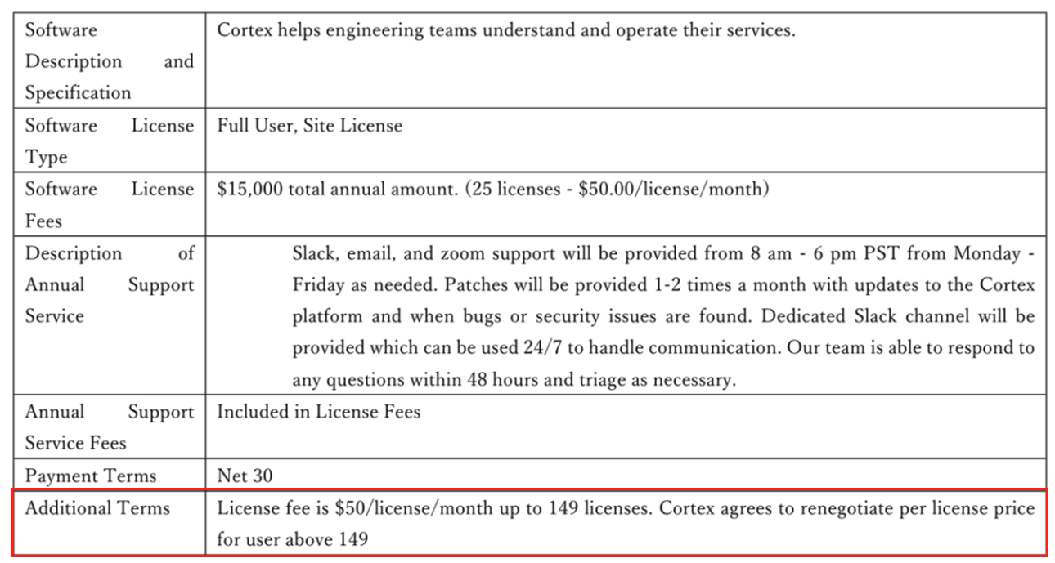

1. Specifics processing things merchant has requested that may differ by contract ~~(e.g. always back-date invoice date to final day of the month)~~
2. Default Service Term
   1. If None Listed, Ops Default is 1 Year
3. Default Net Payment Terms
   1. If None, Default to Net 30
4. Default Billing Frequency
   1. If None Listed, Ops Default is Monthly
5. How do we handle taxes as a line item?
   1. If None Listed, Ops Default is every tax line item becomes a BT

### Events Processing (if necessary)

* N/A

Integration Items Processing (if necessary)

* What are the instructions for assigning integration items?
  + Integration item - default to **Deferred Revenue - Subscription IDP** for all

Post Processing Communications (if necessary)

* Does Ops Team need to notify anyone on the team re: completion of processing batches in Implementation or Active phase?
* Who needs to be notified and when?
  + Example:
    - Who: Customer Success [Azmat Aziz] needs to be notified
    - Where: Messari internal merchant channel
    - When: contracts are processed [Merchant Phase: Active]

### Customer Information

* Any important information on specifics customers of this merchant
  + Special memo’s certain invoices require
  + Invoice changes due to merchant/customer relationship

### Feature Requests

* FR 1
  + What is it
  + Why it's important
  + Urgency

### Rewatch Calls

* Rewatch by dates